Game Development

IT6034 Project

Endless

**Game Design Document**

Name: Vitor Cazella

Student ID: 91050051

# Game Details

## Name

Endless

## Team

Design, Production and Coding: Vitor Antunes Cazella

## Date of last update

23 September 2020

# Characters and Assets

|  |  |
| --- | --- |
| **Sketch** | **Used** **asset** |
| Spaceship |  |
| Shoot |  |

**Level’s background**

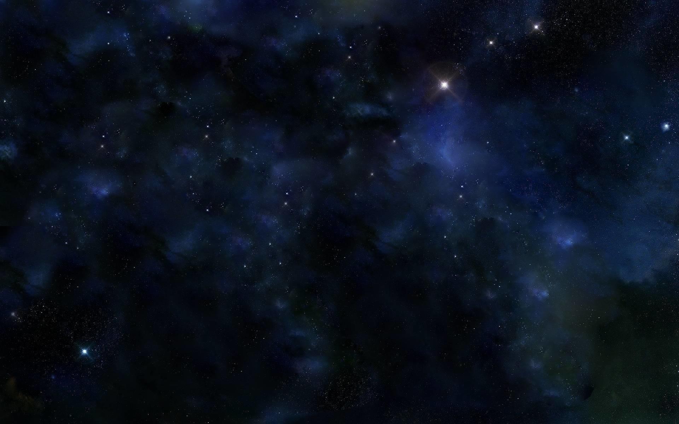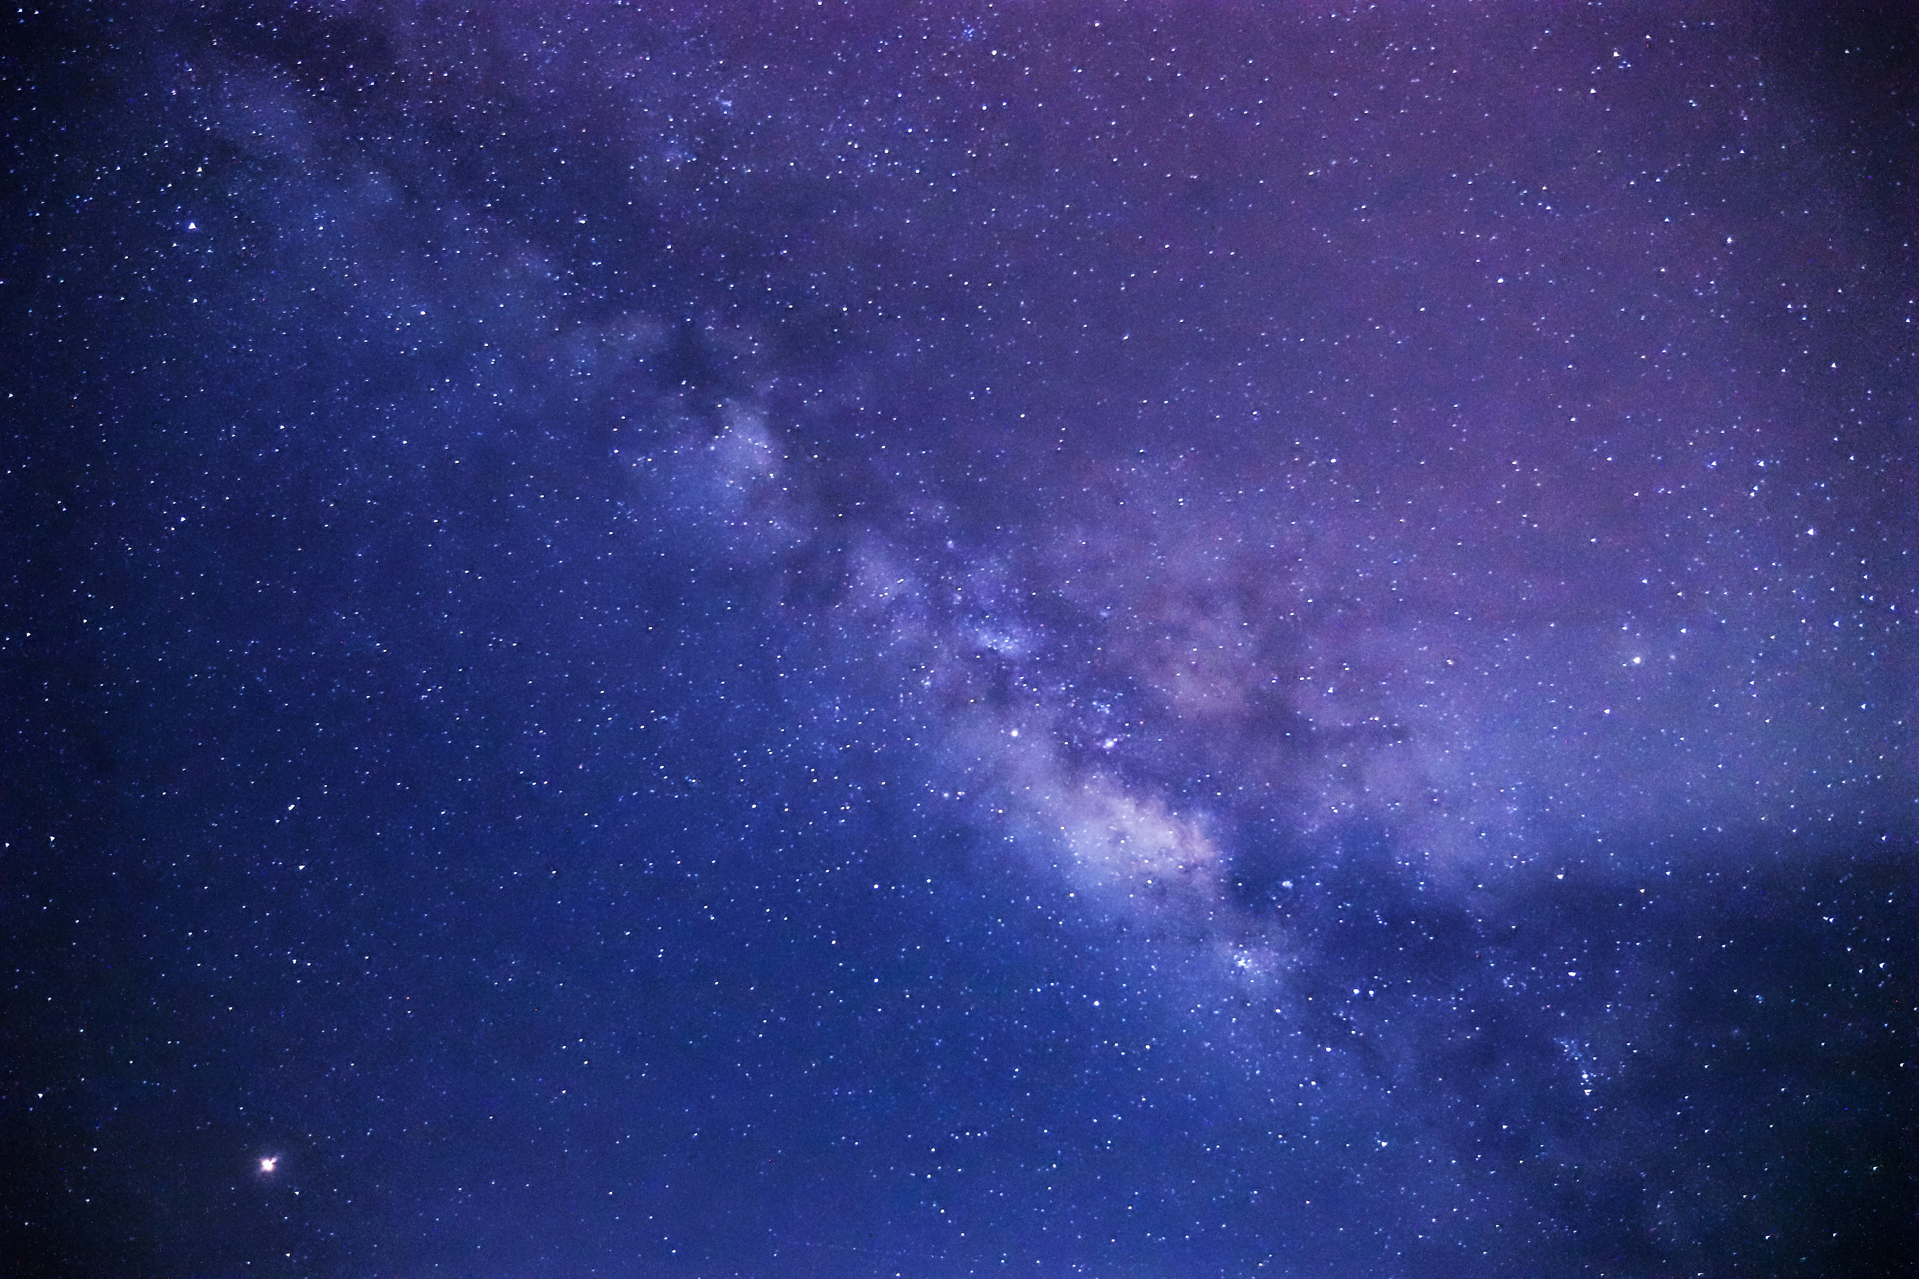

**Asteroids and others**

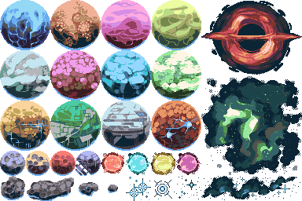

# Game Flow Summary

Start screen

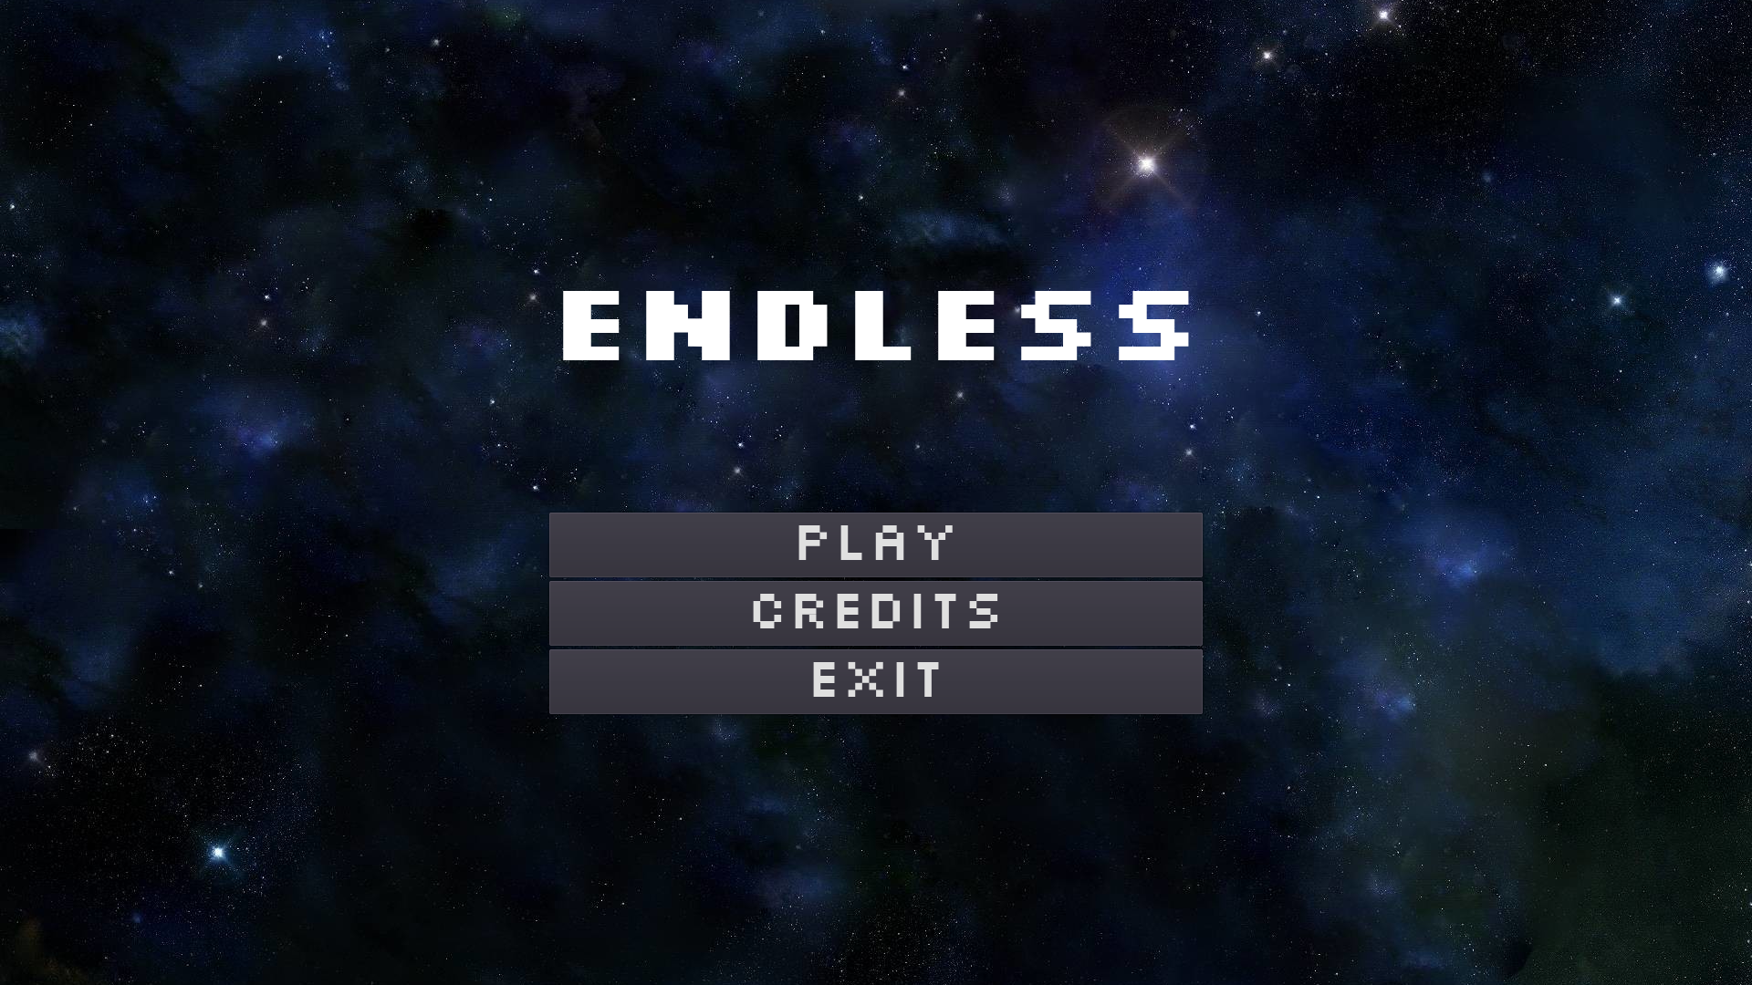

Level 1

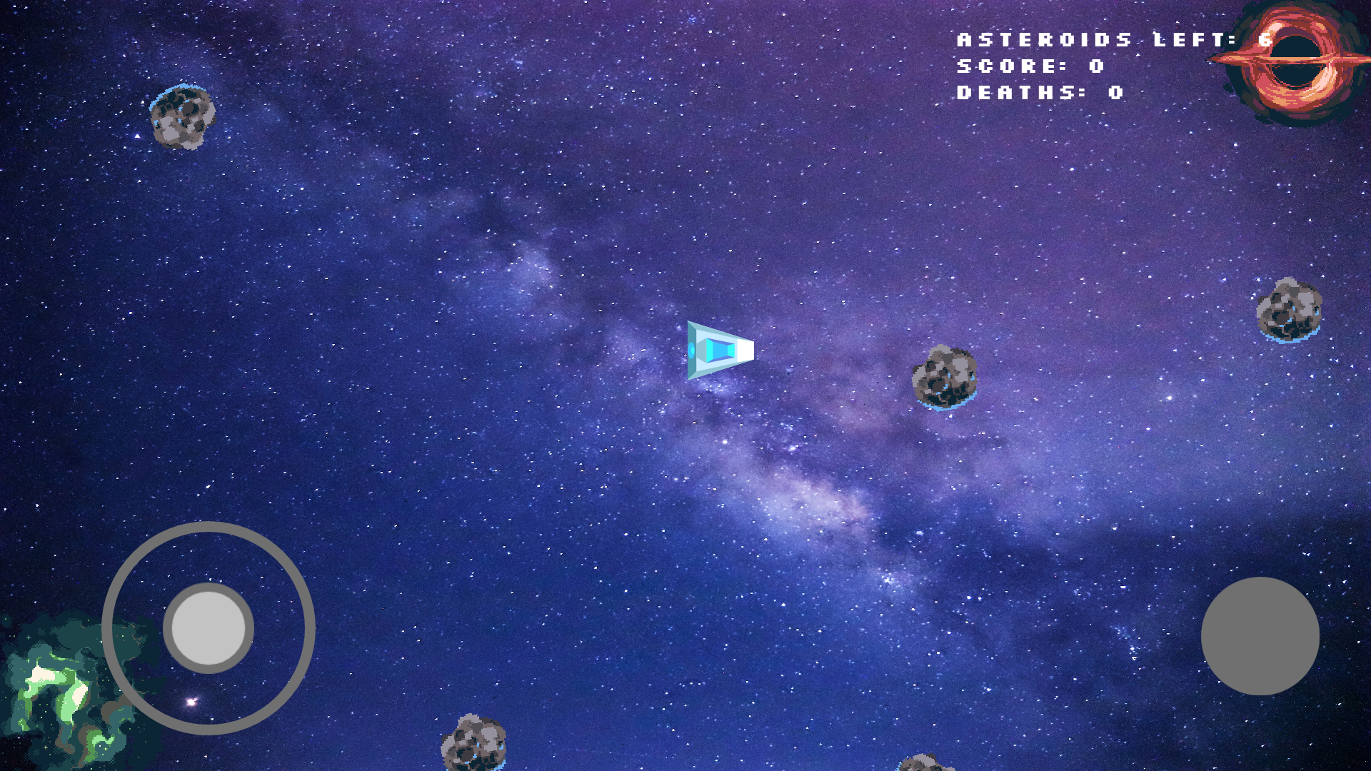

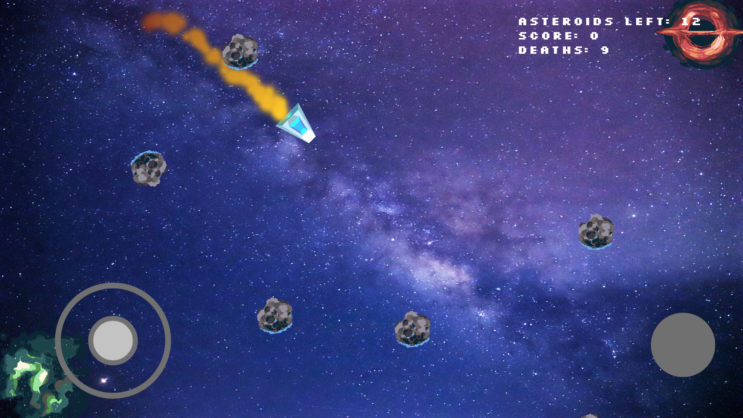

Level 2

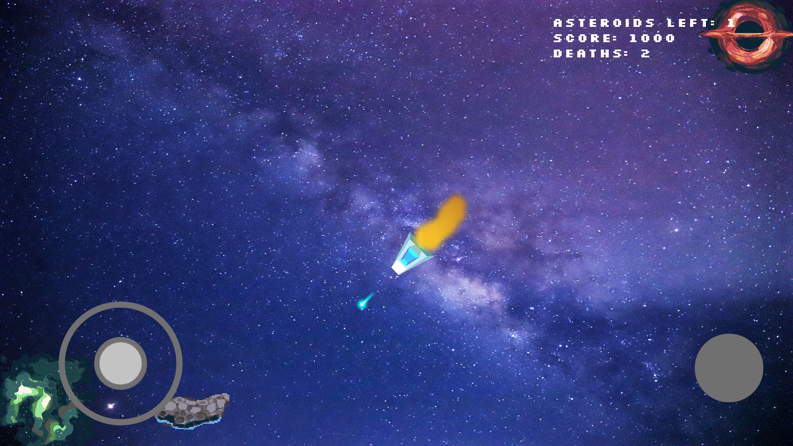

Game Over screen

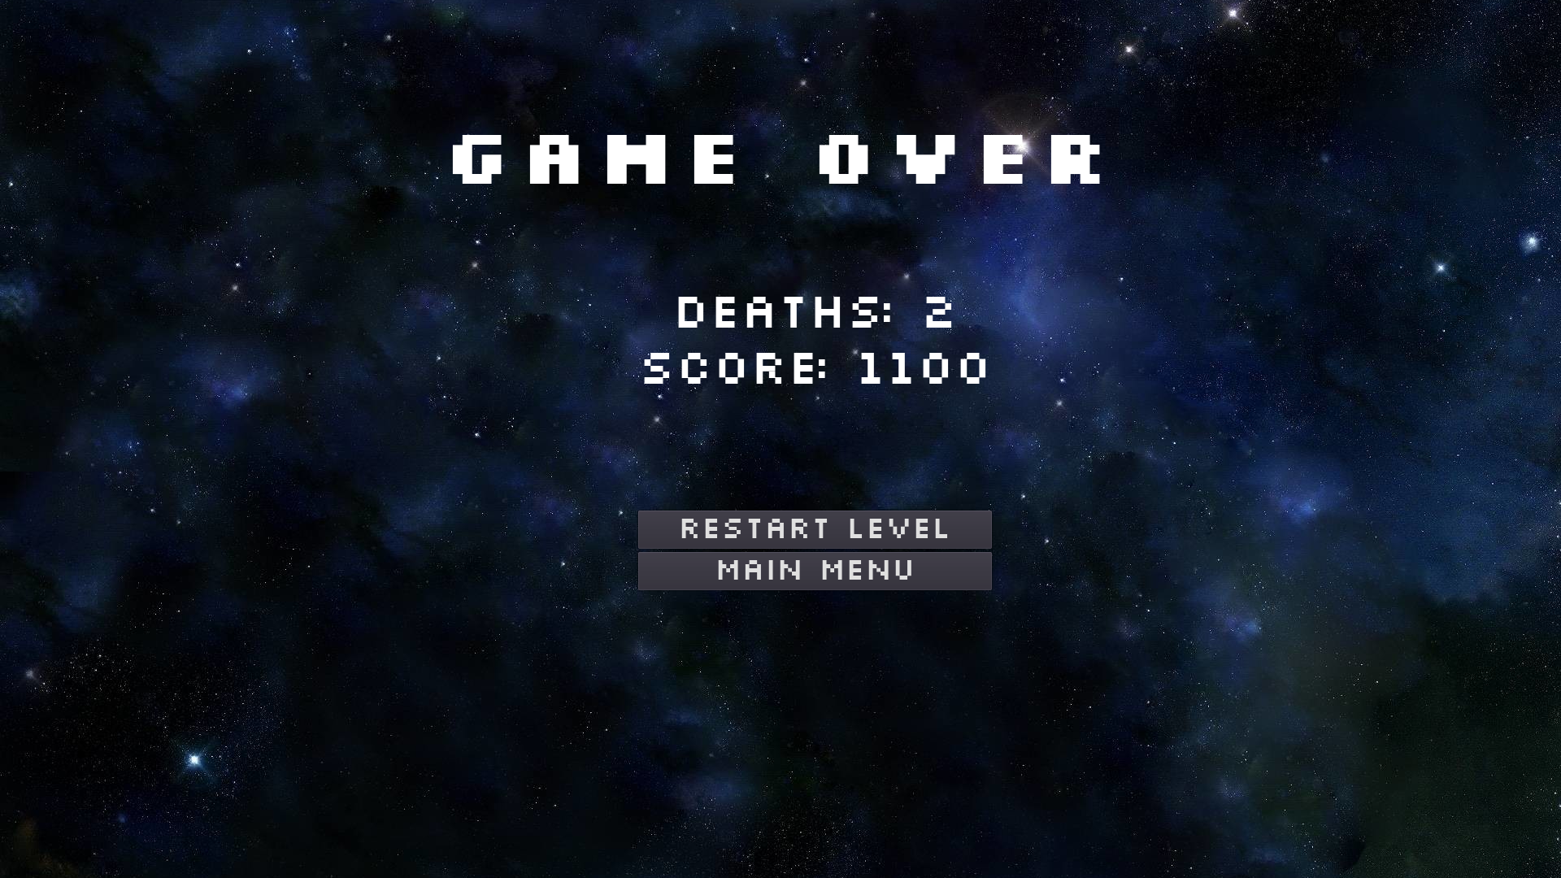

# Gameplay

### How to play

* Windows PC
  + Use arrow keys to move the spaceship
  + Use spacebar to shoot
* Android
  + Left joystick controls the spaceship
  + Right button to shoot

### Objective

The player goal is to destroy all asteroids to finish the level, using your weapons to do so.

### Rules

When the ship touches an asteroid it resets the current level,

Score: Every asteroid destroyed adds 100 point to the player score.

### Physics

Since the game has a space theme I used functions like “apply_friction()”, created to simulate a smoother experience.

func apply_friction(amount):

if motion.length() > amount:

motion -= motion.normalized() * amount

else:

motion = Vector2.ZERO

The code above gradually decreases the ship’s motion.

# Development Log (GitHub)

|  |  |  |
| --- | --- | --- |
| **Date of Commit** | **Change** | **Description** |
| Tue - Sep 1, 2020 | Starting project | I started creating the player and adding its moviment scripts |
| Wed - Sep 2, 2020 | Movement modifications |  |
| Thu - Sep 3, 2020 | Changed character's design | Used the first ship design |
| Mon - Sep 7, 2020 | Working on the bullets | Coding the shoot function |
| Tue - Sep 8, 2020 | Working on a pause menu | One feature that I was working in |
| Thu - Sep 10, 2020 | Working on the pause system | However I ended up leaving this idea aside for project prototype |
| Mon - Sep 14, 2020 | Player particles | Using Particles2D node to create the ship thrusters |
| Tue - Sep 15, 2020 | Joystick | Using a open sorce asset on godot |
| Wed - Sep 16, 2020 | Joystick adapted | Adapted asset for the user’s interface |
| Wed - Sep 16, 2020 | Working on asteroid spawner | Another feature for the game first idea |
| Thu - Sep 17, 2020 | Working on despawn function | However, I postponed it to the next game version |
| Sat - Sep 19, 2020 | Asteroids working with manual path |  |
| Mon - Sep 21, 2020 | Score ready with asteroids in place | Figured how to use a global script to store game data to be changed in between different scenes |
| Mon - Sep 21, 2020 | Score working and added to the HUD |  |
| Tue Sep - 22, 2020 | Menu and game over screen |  |
| Tue Sep - 22, 2020 | Scenes finished | Exported to apk and executable for android and PC |